**“Smart toll collection system”**

SUBMITTED in partial fulfillment of the

requirementfor the award of the degree

of

**BACHELOR OF ENGINEERING**

**IN**

**COMPUTER SCIENCE & ENGINEERING**

**Submitted By**

**ABHIJIT DEURI (16/376)**

**HIRAK JYOTI BUNGRUNG (16/378)**

**RISHIK CHANDAN (17/548)**

**Guided By**

**MR. MRIDUL JYOTI ROY**

**(Assistant Professor)**

**

**2016-20**

**GAUHATI UNIVERSITY, GUWAHATI**

**ASSAM ENGINEERING COLLEGE, JALUKBARI**

**GUWAHATI-781013**

**December-2019**

**“Smart toll collection system”**

SUBMITTED in partial fulfillment of the

requirementfor the award of the degree

of

**BACHELOR OF ENGINEERING**

**IN**

**COMPUTER SCIENCE & ENGINEERING**

**Submitted By**

**ABHIJIT DEURI (16/376)**

**HIRAK JYOTI BUNGRUNG (16/378)**

**RISHIK CHANDAN (17/548)**

**Guided By**

**MR. MRIDUL JYOTI ROY**

**(Assistant Professor)**

**

**2016-20**

**GAUHATI UNIVERSITY, GUWAHATI**

**ASSAM ENGINEERING COLLEGE, JALUKBARI**

**GUWAHATI-781013**

**December-2019**

**CONTENTS**

**Page No.**

**Forwarding Certificate** i

**Forwarding Certificate** ii

**Acknowledgement** iii

**Declaration by Candidates** iv

**Abstract** v

**List of Figures** vi

**List of Tables** vii

|  |  |  |
| --- | --- | --- |
| **Chapter 1:**  **INTRODUCTION** | | **1** |
| 1.1: | Motivation | 2 |
| 1.2: | Problem Statement | 2 |
| 1.3: | Goals and Objectives | 3 |
| 1.4: | Proposed System | 3 |
| 1.5: | Specific Objectives | 4 |
| 1.6: | Significance of the project | 4 |
| 1.7: | Scope and Limitation of the project | 5 |
| **Chapter 2 :**  **LITERATURE REVIEW** | | **6** |
| 2.1.1: | Introduction | 7 |
| 2.1.2: | Existing System | 7 |
| 2.1.3: | Overview of the Proposed System | 10 |
| 2.1.4: | Database System | 11 |
| 2.2: | Methodology | 13 |
| 2.2.1: | Functional requirements | 13 |
| 2.2.2: | Non-functional requirements | 13 |
| 2.2.3: | Hardware Requirement | 14 |
| 2.2.4: | Phases of implementation | 14 |
| 2.2.4.1: | Image capturing | 14 |
| 2.2.4.2: | Image Detection | 15 |
| 2.2.4.3: | Image Extraction | 29 |
| 2.2.4.4:  2.2.4.5: | Image Recognition  Data Storage Phase | 30  31 |
| 2.3: | System Design | 32 |
| 2.3.1: | Software Design | 33 |
| 2.3.1.1: | Database Design | 33 |
| 2.3.1.2: | Views in phpMyAdmin | 33 |
| 2.3.2: | SMS4India API | 35 |
| **CHAPTER 3 :**  **Results and Discussion** | | **38** |
| 3.1: | Results | 39 |
| **CHAPTER 4 :**  **CONCLUSION AND FUTURE SCOPE** | | **41** |
| 4.1: | Conclusion | 42 |
| 4.2: | Future Scope | 42 |
| **REFERENCES** | | **43** |



DEPARTMENT OF COMPUTER SCIENCE & ENGINEERING

**ASSAM ENGINEERING COLLEGE::JALUKBARI**

**GUWAHATI-781013**

**Forwarding Certificate**

This is to certify that**ABHIJIT DEURI (16/376), HIRAK JYOTI BUNGRUNG (16/378), RISHIK CHANDAN (17/548)** has/have carried out the project work **Smart toll Collection system** under the supervision of **Mridul Jyoti Roy** and has/have compiled this thesis reflecting the candidate’s work in the semester long project. The candidate(s) did this project full time during the whole semester and the analysis, results, claims etc. are all related to his/her/their studies/study and works during the semester.

We recommend submission of this thesis as the partial fulfillment of the requirement for the degree of Bachelor of Engineering in Computer Science & Engineering of Gauhati University.

**Prof. Dinesh S. Pegu** **External** (HOD) Name:………………...

Computer Science & Engineering Signature:……………..

Assam Engineering College Affiliation:……………..

Jalukbari , Guwahati – 781013



DEPARTMENT OF COMPUTER SCIENCE & ENGINEERING

**ASSAM ENGINEERING COLLEGE::JALUKBARI**

**GUWAHATI-781013**

**Forwarding Certificate**

This is to certify that **ABHIJIT DEURI (16/376), HIRAK JYOTI BUNGRUNG (16/378), RISHIK CHANDAN (17/548)** has/have carried out the project work **Smart Toll Collection System** under my supervision and has/have compiled this thesis reflecting the candidate’s work in the semester long project. The candidate(s) did this project full time during the whole semester and the analysis, results, claims etc. are all related to his/her/their studies/study and works during the semester.

I recommend submission of this thesis as the partial fulfillment of the requirement for the degree of Bachelor of Engineering in Computer Science & Engineering of Gauhati University.

## Mr. Mridul J. Roy

(Assistant Professor)

Signature:

Department of

Computer Science & Engineering

Assam Engineering College, Jalukbari

Guwahati - 781013

**ACKNOWLEDGEMENTS**

The success and final outcome of this project required a lot of guidance and assistance from many people and we are extremely privileged to have got this all along the completion of our project. All that we have done is only due to such supervision and assistance and we would not forget to thank them. We would like to express our heartfelt gratitude to each and every person connected with the completion of this project. Especially, we would like to thank god for his eternal presence.  
We are grateful to our guide Prof. Mridul Jyoti Roy, Department of Computer Science and Engineering, Assam Engineering College, for guiding us throughout the course of our work and providing significant input for the completion of our project. Secondly, we would like to thank Mr Dinesh Shankar Pegu, HOD, Department of Computer Science and Engineering, and Dr. Atul Bora, Principal, Assam Engineering College, Jalukbari, Guwahati-13, for giving us the opportunity to carry out our research project work in this prestigious Institution. We would also like to take this opportunity to thank our family and friends who provided us continuous mental support which helped us in the completion of this project.



Assam Engineering College

**DEPARTMENT OF COMPUTER SCIENCE & ENGINEERING**

**GAUHATI UNIVERSITY**

**Declaration by the Candidate**

We **ABHIJIT DEURI (16/376), HIRAK JYOTI BUNGRUNG (16/378), RISHIK CHANDAN (17/548)** BE. student(s) of the Department of Computer Science & Engineering, Assam Engineering College hereby declares that I/we have compiled this thesis reflecting all my/our works during the semester long full time project as a part of my BE curriculum.

We declare that we have included the descriptions etc of my project work, and nothing has been copied/replicated from other’s work. The facts, figures, analysis, results, claims etc depicted in my/our report are all related to my full time project work.

We also declare that the same report or any substantial portion of this project report has not been submitted anywhere else as part of any requirements for any degree/diploma etc.

Date:

Roll No 16/376 Name - Abhijit Deuri Signature…………….

Roll No 16/378 Name - Hirak Jyoti Bungrung Signature…………….

Roll No 17/548 Name - Rishik Chandan Signature…………….

**ABSTRACT**

Nowadays almost all highways toll plazas are manually operated, where an operator collects cash from the driver. Since this procedure can be slow, we often encounter traffic jams at the toll plazas on busy highways. Automatic process of toll collection will save time, effort, and man power. In this work, we propose a low cost and efficient technique called Smart Toll Collection using Automatic Number Plate Recognition that automatically detects the vehicle’s number plate by applying various pre-processing techniques on the input car image and then either by detecting contours or by using Haar Cascade Method, the number plate could be masked and segmented out which will then be identified using PyTesseract(OCR) and toll will be collected from the owner’s account when they cross the toll plaza. The owner will also be notified that his/her car passed through the toll plaza at the given time. We also assume that an owner maintains an e-wallet, so that toll tax is deducted automatically from that account at toll plaza after recognition of that particular number plate. Using this method of toll collection, the existing manual and semi-automatic RFID system’s drawbacks can be eliminated. Through this process of collection of toll time, effort and man power will be saved.

**LIST OF FIGURES**

|  |  |  |
| --- | --- | --- |
| **Figure No:** | **Name of Figure** | **Page No.** |
| 2.1: | System flow of the Existing system. | 7 |
| 2.2: | Phases of implementation | 4 |
| 2.3: | Adaptive Thresholding | 16 |
| 2.4: | Edge detection algorithm | 17 |
| 2.5: | Contour Detection | 19 |
| 2.6: | Haar Feature types | 23 |
| 2.7: | Haar features being detected | 23 |
| 2.8: | The structure of AdaBoost | 25 |
| 2.9: | Structure of Cascade Classifier | 25 |
| 2.10: | System pipeline | 30 |
| 2.11: | View in phpMyAdmin panel |  |
| 3.1:  3.2: | Results graph  Time comparsion Graph | 32  33 |

**LIST OF TABLES**

|  |  |  |
| --- | --- | --- |
| **Table No:** | **Name of Table** | **Page No.** |
| 1: | SMS4India API variables | **32** |

**Chapter 1 - Introduction**

**1.1 Motivation**

The major motive to develop this project is the need to have an efficient toll collection system that will maximize the annual toll collection amount and that at the same time minimizes the time spent at the toll pay point. This will ultimately help our government to achieve more in its development plans for the people concerned with the increased toll tax collection and reduce time wasted by congestion.

**1.2 Problem Statement**

“Design an Automatic toll plaza which is based on Machine learning to save the time at toll plaza and having cash free operation” As the name suggests “Automatic Toll Plaza” is the key theme of our project. So here we will just discuss about the over look of what is mean by Automation. So in very simple language the Automation means to replace the human being with the machines to reduce human work. Means the work done by the human is now performed by machines.

The most common approach for collecting tolls was to have the driver stop and pay a toll collector sitting in a tollbooth.

A manual lane can process approximately 100 vehicles per hour. So there is multiple lanes on toll booth. These increase the labor cost, fuel consumption, required time, financial loss.

To find the stolen vehicle police need to search separately.

Hence we proposed a system Smart Toll Collection.

**1.3 Proposed solution**

The proposed is automated prepaid system to detect, process and notify the vehicle owner about the remained balance, repay and if not registered to the system after using/passing the (toll station) bridge because charges will be performed automatically online for those registered vehicles and if they are not registered there will be an alert to register and those vehicles from abroad they will have their private lanes to use with an exception of Ambulance, Police and military vehicles which will use the prepaid lanes with no email or text notification to register or pay when use the prepaid lanes .

**1.4 Goals and Objectives**

* Develop effective and fast toll collection system. Effective in term, it eliminates financial leakage.
* Collection of the toll and vehicle identification is done at the same time because of this time delay gets eliminated.
* SMS system that notifies the owner of the vehicle the time and place where the car has been last tolled.
* To provide easy and better way to collect toll.
* To avoid paper work, time consumption and cash payment.
* To reduce time at tollbooth and reduce traffic; which in turn leads to the prevention of the need for extra lanes.

**1.5 Specific objectives.**

1. To design and implement a number plate recognition system for capturing and convert image to variable digits.
2. Designing a database that keeps records of all the registered vehicles that use the toll station, the information contained is the vehicle’s registration number, owner’s identification and the billing information.
3. Designing a system which takes a picture of the vehicle and identifies it with reference to our inbuilt database. Opens the gate after identification has been done and closes it after the vehicle has passed.
4. To implement hardware and software parts of the proposed system to reflect the real design process and integrate the software and hardware parts to make a complete control system.

**1.6 Significance of the Project**.

The successful completion of the project and its implementation at any specified toll station will have the following advantages;

The driver doesn't have to carry the money each time, He or she will just recharge the account and the amount and will be used at each time of crossing the bridge.

Efficient toll collection that earns the government much income.

Low time spent at the toll pay point

Reduced oil consumption because of the non-stop passing of the toll pay points. Therefore it increases fuel economy.

Reduce air pollution due to auto-emissions at the specified station is reduced to large extent and Speedy transportation due to less congestion at the toll collection point.

**1.7 Scope and Limitation of the Project.**

The project concerns with application of a License Plate Recognition system and processing the obtained number plate digits to perform online debits / payment and notify the vehicle owner through email or SMS to top-up his/her account and all functions will be done without stopping of the vehicle (Toll tax at non-stop vehicles).

The design consideration can be applied at any vehicle entry point where toll tax is concern. The system is power dependent and so with the current power shortage, a standby power source should be used.

**Chapter 2 - Project Work**

**Literature Review**

**2.1.1 Introduction**

Literature review involved taking time to read different documents from text of scholar offline and in web sites. Furthermore, it provides the necessary knowledge and information obtained from various information sources. The reading built up the knowledge and new techniques toward implementation of this project. These readings includes substantive findings, theoretical and methodological contributions to a particular topic, consulting project supervisor, lecturers and other professionals to get a clear knowledge of the system to be implemented.

**2.1.2 Existing System**

There are two ways toll collection can be done:

1. Manual collection
2. RFID System (Semi-Automatic)
3. **Traditional toll (Manual Collection)**

Traditional toll collection system or manual toll collection system is the simplest form oftoll collection, in which a collector operating from a booth collects the toll. This methodis slower and sometimes not perfect also. One or two persons sit in the toll collectionbooth and stop each vehicle to collect the toll manually. The collector gives a memo tothe drivers as a record of toll payment. Moreover, in Bangladesh lots of corruptions arehappening in this sector. There is no central controlling system for the toll collection, allthe information regarding payments ad vehicles are not saving in a database or website.

1. **RFID System (Semi-Automatic)**

The currently technology used for charges of vehicle at toll stations is operated in a semi-automatic system (RFID system) which employ the number of procedures to perform toll tax charges per single vehicle.

RFID is the technology which uses electromagnetic waves that have a wavelength suited for use in radio communication. Radio waves are classified by their frequencies, which are expressed in kilohertz, megahertz, or gigahertz and power. Radio frequencies range from very low frequency (VLF), which has a range of 10 to 30 kHz, to extremely high frequency (EHF), which has a range of 30 to 300 GHz.

Radio Frequency Identification (RFID) is an automated data capture method that uses radio frequency waves to transfer data between a reader and a movable item so as to automatically identify it. It is an auto identification technology which uses Radio Frequencies (between 30 kHz and 2.5GHz) to identify objects remotely. This system does the job of detecting, billing and accounting for vehicles as they pass through a toll station using RFID as the identification technology which uses a card and bar code scanner for tickets.

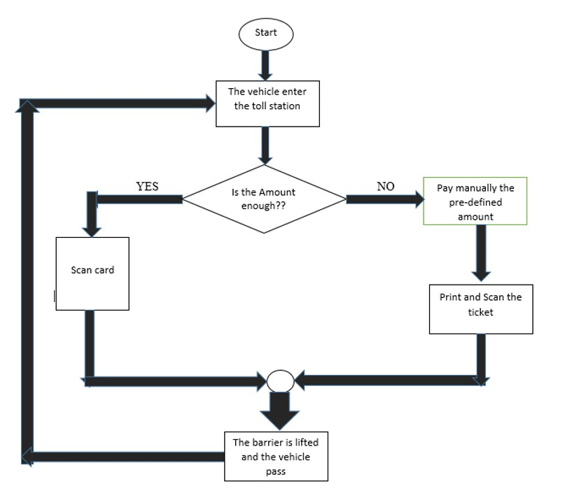

**Figure 2.1: System flow of the Existing system.**

Along with the development of vehicle transport the use of highway traffic will be more and more and the toll tax charges form of manual and semi-automatic will not meet demand of the charging management system and many vehicle may be blocked at entrances causing huge economic losses when it reach a certain edge. The use of no parking on the highway shows a great potential in solving these problems. For ETC applications, a sufficient communication time interval is necessary to allow for the complete transfer of all the information between roadside units (detection components) and server while the vehicles are rapidly passing through the toll station.

**Disadvantages of the existing System:**

The main disadvantages of the existing system are:

1. It is time consuming and therefore causes congestion at the toll station.
2. It is an inefficient toll collection method since some vehicle owner can negotiate with operator.
3. It is highly susceptible to human errors since it is manually operated and dependent on operator speed.
4. It is time consuming hence not suitable for many number of vehicles because a lot of time is wasted in waiting for toll tax collection.
5. It needs an operator to be available at all the time waiting for vehicles.

**FASTag VS our model**

FASTag is a simple to use, reloadable tag which enables automatic deduction of toll charges and lets you pass through the toll plaza without stopping for the cash transaction. FASTag is linked to a prepaid account from which the applicable toll amount is deducted. The tag employs Radio-Frequency Identification (RFID) technology and is affixed on the vehicle's windscreen after the tag account is active.

It is stated that it will let the car pass through without stopping the car but in reality, it does not work that way. In most toll plazas, there exists an operator who uses a hand-held RFID reader to read the tag after stopping the car. Hence, creating some delay.

• Sometimes the hand-held device becomes faulty as well.

• The battery of the hand-held RFID reader needs to be recharged.

• In some toll plazas, there is only one hand-held unit for 3–4 lanes causing great delay.

In our model, we do not need a hand-held RFID reader. We just need a camera properly fitted at the toll-gate that will be lifted open when the car’s license plate has been recognized. The camera must be fixed firmly to the toll gate with protection against rain and heavy wind.

**How our model could be better**

Although FASTag seems to overcome most of the drawbacks of the existing manual toll collection system, but however there are certain drawbacks which are left unsolved/provoked by using it.

• Local people – monthly pass – From the inception of the Fastag itself, it shows no help to distinguish between the people dwelling near the toll booth area and hence creating a monthly pass. So in order to overcome this, in our model we have tried to add an additional information about the location of the user’s home in our database. And we have tried to provide a monthly pass based on the information. (Monthly pass is granted, if the user’s home is within 10kms range from the toll booth).

• The tags are not bank neutral – It seems that Fastag facilitates cashless transaction, but the tags sold by banks are not “bank neutral”. Our proposed system could remove this drawback as we have a wallet which is open for all the banks.

• Security- It may be possible for persons with malicious intent to use a RFID scanner to obtain sensitive information about vehicle owners from the tags and this information can be used for crimes. However in our system we store the information in our secured database which can only be accessed by the administrators and operators, keeping the sensitive information safe.

• Fastag stickers are best utilized in confined, controlled spaces – If the frequencies of the tags gets collided within the range of the scanner, the readability can get affected.

• Double charge- Vehicles entering Fastag lanes without Fastag will be charged twice the toll amount as RFID systems fails to keep any record if there is no tag attached. Our system overcomes this drawback as it will recognize the number plate and keep the vehicle on record. So that whenever the vehicle owner opens up the account the toll could be collected.

But certain drawbacks are still required to overcome by both FASTag as well as by our proposed system. Like dirt, scratches, damage and frequency of use can impact readability of the stickers and in our case as well, dirt and fading of the number plate can affect the recognition phase.

In this way, the inconsistencies of the FASTag will be eliminated/reduced by using our model of toll collection.

But certain drawbacks are still required to be overcome by both FASTag and as well as by our proposed system. Factors like dirt, scratches, damage and frequency of use can impact readability of the stickers and in our case as well as dirt and fading of the number plate can affect the recognition phase. High quality images are also required to be properly detected by our model.

**2.1.3 Overview of the Proposed System.**

The proposed system is an Electronic Toll Collection System is just the right solution for the problems and shortcomings of the RFID technology in terms of toll tax collection. An Electronic Toll Collection is a kind of technology that will allows for electronic payment of tolls and it can determine whether a vehicle has been registered or not registered in an ETC toll payment program, alert the enforcers if toll payment violation occurs and debit the corresponding account.

Considering the application of an ETC system the driver does not have to stop the vehicle to implement toll payment because an ETC system is an electronic automatism toll collection system that would be used in the highway, bridge and tunnel (If Tanzania design it in the next generation). The use can be extended to parking lots. Its obvious advantage is no parking toll tax collection and the vehicle can be at a high speed throw the toll station instead of which has to slow down before toll station and park to charge.

The development of vehicle transport and the use of highway traffic will be more and more and the toll tax form of manual and semi-automatic will not meet demand of the charging management system and many vehicle may be blocked at entrances and exits causing huge economic losses when it reach a certain edge. The use of no parking on the highway shows a great potential in solving these problems.

**2.1.4 Database System**

Database is a shared collection of logically related data and a description of this data designed to meet the information needs of an organization. It is therefore a single repository of data that can be used simultaneously by various users. All data items are integrated with a minimum duplication instead of having several disconnected files with redundant data. The database is also defined as a self-describing collection of integrated records because it contains the organization’s operational data but also a description of this data.

In this project, the database system holding all the necessary information related to the vehicles registered to use a toll station. This includes fields like its registration number, the balance, amount paid for the vehicle, details of its registered vehicle and the details of its owner.

**Types of Databases**

There are several types of databases example external database, analytical database, operational database, distributed database, real time database. But all these are all mainly divided into two types:

**Relational database**: is a collection of normalized relations with distinct relation names. This is a standard of business computing and it uses tables to structure information.

**Flat file databases**: Flat files are the ones in which the records in the file contain no information to communicate the file structure or any relationship among the records to the application that using the file. Any information about the structure or meaning of the data in the file must be included in each application that uses the file or must be known to each human who reads the file. The manual filing system is suitable we either want to store small or data or when we only want to store or retrieve large data.

**Database Language used.**

MySQL is the database designing languages that used in this project. This is a non-procedural language whereby the user specifies the information that he or she wants rather than how to get the information. In other words, it is a language that does not require the user to specify the access methods.

**Methodology**

**2.2.1 Functionalrequirements**

The following are the system functional requirements of the system;

* The system should be able to identify, recognize and authenticate the vehicle.
* The system should be able to detect and recognize the vehicle number plate.
* The system should be able compare and check if the number plate exists in database or not existing.
* The system should be able to perform online payment and store & keep records.
* The system should be able to notify the owner if the number does not exist or insufficient balance.

**2.2.2 Non-functional requirements**

Non-functional requirements define the overall qualities or attributes of the resulting system. Non-functional requirements are constraints of the product developed that must meet to make the system useful. These includes the following:

* **Performance** – The system use short response time, high throughput and easy Utilization.
* **Usability** - The system is easy to use for any user.
* **Scalability**- The system can be extended to increase total throughput under an increased load when resources (typically hardware) are added.
* **Availability**- the system is available for service when requested by the user at any time.
* **Reliability**- the system performs its required functions under stated conditions for a specific period of time.
* **Maintainability**- the system is maintainable to incorporate other functionalities.
* **Security**- Unauthorized access to the system is not allowed.

**2.2.3 Hardware Requirement.**

The list below is the hardware components required to complete the project design and implementation of the smart recognition of vehicles for electronic toll collection system.

**2.2.4 Phases of implementation**

The procedural development of proposed system components are grouped into five different phases, based on the function carried out by the modules of the prototype as briefly described in this section.

1. Image Capturing
2. Image Detection
3. Image Extraction
4. Image Recognization
5. Data storage space

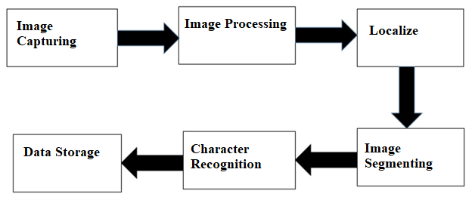  
**Figure 2.2 : Phases of implementation**

**2.2.4.1 Image capturing**

Image acquisition is done by the USB Image capture camera which captures the image when it is triggered. The positioning of the camera will be structured to get the image of the number plate for the front part of the ongoing vehicle approaching the toll station.

**2.2.4.2 Image Detection**

After digital image has been obtained and send to the system next step is to deal with pre-processing of the image. The main purpose of the pre-processing is to increase the efficiency of character recognition which includes the set algorithms applied on the images to enhance the quality while obtaining the correct characters required. It is an important phase in the system

In this phase we will be detecting the License Plate region of the vehicle that has arrived. The pre-processing techniques used are as follows:

**Resize**: Some images captured by a camera and fed to system vary in size, therefore, we should establish a base size for all images fed into our system.

**Gray scale conversion**: Grayscale images consist of only gray tones of colors, which are only 256 steps. In other words, there are only 256 gray colors. The main characteristic of [grayscale](https://www.sciencedirect.com/topics/engineering/grayscale) images is the equality of the red, green, and blue color levels. The [color code](https://www.sciencedirect.com/topics/engineering/colorcode) will be like RGB(R,R,R), RGB(G,G,G), or RGB(B,B,B) where ‘R,G,B’ is a number between 0 and 255 individually. Gray Scale conversion is used to reduce the computation power needed to process the input images.

**Binary Conversion**

**Simple Thresholding**

In simple thresholding, if pixel value is greater than a threshold value, it is assigned one value (may be white), else it is assigned another value (may be black). The function used is cv2.threshold. First argument is the source image, which should be a grayscale image. Second argument is the threshold value which is used to classify the pixel values. Third argument is the maxVal which represents the value to be given if pixel value is more than (sometimes less than) the threshold value. OpenCV provides different styles of thresholding and it is decided by the fourth parameter of the function. Different types are:

cv2.THRESH_BINARY

cv2.THRESH_BINARY_INV

cv2.THRESH_TRUNC

cv2.THRESH_TOZERO

cv2.THRESH_TOZERO_INV

Below is a sample code for simple thresholding

import cv2

import numpy as np

from matplotlib import pyplot as plt

img = cv2.imread('gradient.png',0)

ret,thresh1 = cv2.threshold(img,127,255,cv2.THRESH_BINARY)

ret,thresh2 = cv2.threshold(img,127,255,cv2.THRESH_BINARY_INV)

ret,thresh3 = cv2.threshold(img,127,255,cv2.THRESH_TRUNC)

ret,thresh4 = cv2.threshold(img,127,255,cv2.THRESH_TOZERO)

ret,thresh5 = cv2.threshold(img,127,255,cv2.THRESH_TOZERO_INV)

titles = ['Original Image','BINARY','BINARY_INV','TRUNC','TOZERO','TOZERO_INV']

images = [img, thresh1, thresh2, thresh3, thresh4, thresh5]

for i in xrange(6):

plt.subplot(2,3,i+1),plt.imshow(images[i],'gray')

plt.title(titles[i])

plt.xticks([]),plt.yticks([])

plt.show()

**Adaptive Thresholding**

In the previous section, we used a global value as threshold value. But it may not be good in all the conditions where image has different lighting conditions in different areas. In that case, we go for adaptive thresholding. In this, the algorithm calculate the threshold for a small regions of the image. So we get different thresholds for different regions of the same image and it gives us better results for images with varying illumination.

It has three ‘special’ input params and only one output argument.

**Adaptive Method - It decides how thresholding value is calculated.**

* cv2.ADAPTIVE_THRESH_MEAN_C : threshold value is the mean of neighbourhood area.
* cv2.ADAPTIVE_THRESH_GAUSSIAN_C : threshold value is the weighted sum of neighbourhood values where weights are a gaussian window.

**Block Size** - It decides the size of neighbourhood area.

**C** - It is just a constant which is subtracted from the mean or weighted mean calculated.

Below piece of code compares global thresholding and adaptive thresholding for an image with varying illumination:

import cv2

import numpy as np

from matplotlib import pyplot as plt

img = cv2.imread('dave.jpg',0)

img = cv2.medianBlur(img,5)

ret,th1 = cv2.threshold(img,127,255,cv2.THRESH_BINARY)

th2 = cv2.adaptiveThreshold(img,255,cv2.ADAPTIVE_THRESH_MEAN_C,\

cv2.THRESH_BINARY,11,2)

th3 = cv2.adaptiveThreshold(img,255,cv2.ADAPTIVE_THRESH_GAUSSIAN_C,\

cv2.THRESH_BINARY,11,2)

titles = ['Original Image', 'Global Thresholding (v = 127)',

'Adaptive Mean Thresholding', 'Adaptive Gaussian Thresholding']

images = [img, th1, th2, th3]

for i in xrange(4):

plt.subplot(2,2,i+1),plt.imshow(images[i],'gray')

plt.title(titles[i])

plt.xticks([]),plt.yticks([])

plt.show()

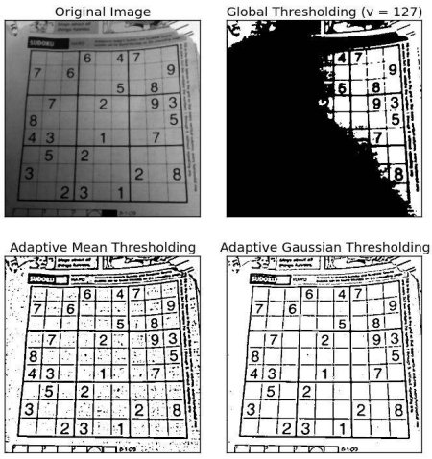

**Figure 2.3 : Adaptive Thresholding**

**Canny-Edge detection**: The Canny edge detector is an [edge detection](https://en.wikipedia.org/wiki/Edge_detection) operator that uses a multi-stage [algorithm](https://en.wikipedia.org/wiki/Algorithm) to detect a wide range of edges in images. It was developed by [John F. Canny](https://en.wikipedia.org/wiki/John_F._Canny) in 1986. Canny also produced a computational theory of edge detection explaining why the technique works.

The Canny edge detection algorithm is composed of 5 steps:

1. Noise reduction;
2. Gradient calculation;
3. Non-maximum suppression;
4. Double threshold;
5. Edge Tracking by Hysteresis.

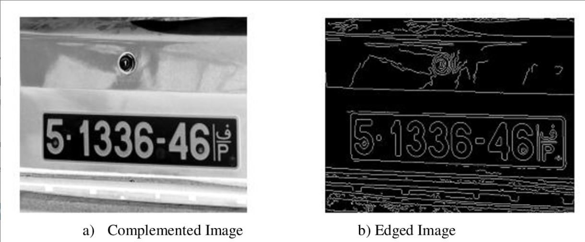

**Figure 2.4 : Edge detection algorithm**

**Morphological operatio**n: Morphological operations are used to extract image components that are useful in the representation and description of region shape. Morphological operations are some basic tasks dependent on the picture shape. It is typically performed on binary images. It needs two data sources, one is the input image, the second one is called structuring component. Morphological operators take an input image and a structuring component as input and these elements are then combines using the set operators. The objects in the input image are processed depending on attributes of the shape of the image, which are encoded in the structuring component.

Two types of **morphologicaloperations** used are

1. **Erosion**- Erosion is one of the two basic operators in the area of mathematical morphology, the other being dilation. It is basically applicable to binary images, but having versions that work on grayscale images. The basic effect of the operator on a binary image is to erode away the boundaries of regions of foreground pixels (i.e., white pixels, typically). Thus areas of foreground pixels shrink in size, and holes within those areas become larger. ?e erosion operator receives two pieces of data as inputs. The first piece is the image which is to be eroded. The second is a (usually small) set of coordinate points known as a structuring element (also known as a kernel). It is this structuring element that determines the precise effect of the erosion on the input image.

2. **Dilation**- Dilation is one of the two basic operators in the area of mathematical morphology, the other being erosion. It is usually applied to binary images, but there are options that work on grayscale images. The basic effect of the operator on a binary image is to gradually enlarge the boundaries of regions of foreground pixels (i.e., white pixels, typically). Thus areas of foreground pixels grow in size while holes within those regions become smaller. The dilation operator takes two pieces of data as inputs. The first piece of the image is dilated. The second part is usually tiny which is set of coordinate points called a structuring element (also known as a kernel). It is this structuring element that determines the precise effect of the dilation on the input image . Dilation of image f by structuring element s is given by the structuring element s is positioned with its origin at (x, y) and the new pixel value is determined using the rule

**Gaussian blur**: Gaussian blur (also known as Gaussian smoothing) is the result of blurring an image by a Gaussian function. It is a widely used effect in graphics software, typically to reduce [image noise](https://en.wikipedia.org/wiki/Image_noise). The visual effect of this blurring technique is a smooth blur resembling that of viewing the [image](https://en.wikipedia.org/wiki/Image) through a translucent screen, distinctly different from the [bokeh](https://en.wikipedia.org/wiki/Bokeh) effect produced by an out-of-focus lens or the shadow of an object under usual illumination. Gaussian smoothing is also used as a pre-processing stage in [computer vision](https://en.wikipedia.org/wiki/Computer_vision) algorithms in order to enhance image structures at different scales.

After the above pre-processing techniques are done, the system now moves on to the object detection by using:

1. Contour Detection.
2. Haar-Cascade method.

**Contour Detection**  
Contour is known as a representative feature of imagery object, and thus, its detection is problem in the field of computer vision. Contour detection algorithms are fundamentally required for performing practical tasks, such as object recognition and scene understanding. Until now, numerous researchers have studied the problem constantly, and have gained significant achievements.

A contour is defined as an outline representing or bounding the shape or form of an object. Contour detection attempts to extract curves which represent object shapes from images. In fact, the concept of contour is based on human′s common experience, which does not have a formal mathematical definition. Contour is closely related to two additional concepts, i.e., edge and boundary, which correspond to the discontinuities in photometrical, geometrical and physical characteristics of objects in images. It is believed that a clear distinction among the three concepts facilitates the feature selection when designing certain special detectors.

A boundary is described as a contour in the image, representing a change in pixel ownership from one object or surface to another. Some researchers tend to regard contours as the boundaries of interesting regions. However, contour detectors cannot guarantee to produce closed contours and divide the image into different regions. These cases will frequently occur when contours do not arise from region boundaries. In this sense, the concepts of contour and boundary are closely related, but not identical.

In addition, an edge is represented in the image by changes in the intensity function and can be detected by certain low-level image features such as brightness or color. Therefore, edge detection is a low-level technique which could be applied toward the goal of boundary or contour detection. As illustrated in the figure below, the four classical means by which contours are observed are luminance change, texture change, perceptual grouping, and illusory contour, respectively. In the first and second cases, the contours arise from regions boundaries, whereas in the third and fourth cases, global relations give rise to the perception of a contour.

|  |  |
| --- | --- |
|  |  |

**Figure 2.5: Contour Detection**

Considering the variety that may emerge from practical applications, contour detection is a difficult task. Generally, the detectors with local features do not achieve satisfactory results, especially for textures, low-contrast objects, or severely noisy images. To pursue better performance, more sophisticated detectors are developed in which high-level information and sometimes prior knowledge (e.g., the shape of the contour to be detected) are also deployed.

In summary, contour detection is of theoretical and practical significance. Despite all of that, there lack overviews of research studies related to this field. To the best of our knowledge, the most recent overview is published in 2011[[1](http://html.rhhz.net/GJZDHYJSJZZ/20180602.htm#b1)]. It focuses mainly on “edge and line oriented approaches”, while other types of approaches are not discussed in depth. Moreover, this review, to some degree, lags behind the development of the era since remarkable progress has been made on this subject. Specially, deep learning techniques[[6](http://html.rhhz.net/GJZDHYJSJZZ/20180602.htm#b6)] are successfully applied to solve the problem of contour detection, achieving comparable performance with the other state-of-the-art methods[[7](http://html.rhhz.net/GJZDHYJSJZZ/20180602.htm#b7)]. Therefore, an overview of the contour detection approaches including the recent progresses is necessary.

Below is a code for Contour Detection :-

import numpy as np

import cv2

import imutils

import glob

try:

import Image

except ImportError:

from PIL import Image

import pytesseract

pytesseract.pytesseract.tesseract_cmd = r"D:/Installed_softwares/Tesseract/tesseract.exe"

no=1

import re

numbers = re.compile(r'(\d+)')

def numericalSort(value):

parts = numbers.split(value)

parts[1::2] = map(int, parts[1::2])

return parts

path = "C:/Users/Hirak/Desktop/Project/DataSet/DataSet/*.*"

for file in sorted(glob.glob(path),key =numericalSort):

image = cv2.imread(file)

image = imutils.resize(image, width=500)

gray = cv2.cvtColor(image, cv2.COLOR_BGR2GRAY)

cv2.imshow("1 - Grayscale Conversion", gray)

gray = cv2.bilateralFilter(gray, 11, 17, 17)

edged = cv2.Canny(gray, 170, 200)

cv2.imshow("4 - Canny Edges", edged)

(cnts, _) = cv2.findContours(edged.copy(), cv2.RETR_LIST, cv2.CHAIN_APPROX_SIMPLE)

cnts=sorted(cnts, key = cv2.contourArea, reverse = True)[:30]

NumberPlateCnt = None

count = 0

for c in cnts:

peri = cv2.arcLength(c, True)

approx = cv2.approxPolyDP(c, 0.02 * peri, True)

if len(approx) == 4:

NumberPlateCnt = approx

break

mask=np.zeros(gray.shape,np.uint8)

cv2.drawContours(mask, [NumberPlateCnt], 0, 255, -1)

mask=cv2.bitwise_and(image,image, mask=mask)

cv2.imshow('mask',mask)

fname='C:/Users/Hirak/Desktop/Project/Plates/img'+str(no)+'.jpg'

cv2.imwrite(fname,mask)

print(file) print(pytesseract.image_to_string(Image.open('C:/Users/Hirak/Desktop/Project/Plates/img'+str(no)+'.jpg')))

no=no+1

cv2.waitKey(5000)

cv2.waitKey(0)

cv2.destroyAllWindows()

**Haar Cascade method**

Object Detection using Haar feature-based cascade classifiers is an effective object detection method proposed by Paul Viola and Michael Jones in their paper, "Rapid Object Detection using a Boosted Cascade of Simple Features" in 2001. It is a machine learning based approach where a cascade function is trained from a lot of positive and negative images. It is then used to detect objects in other images.

Here we will work with face detection. Initially, the algorithm needs a lot of positive images (images of faces) and negative images (images without faces) to train the classifier. Then we need to extract features from it. For this, Haar features shown in the below image are used. They are just like our convolutional kernel. Each feature is a single value obtained by subtracting sum of pixels under the white rectangle from sum of pixels under the black rectangle.

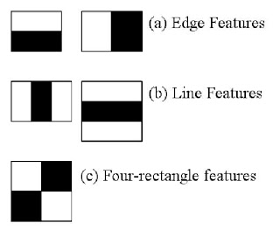  
**Figure 2.6: Haar feature types**

Now, all possible sizes and locations of each kernel are used to calculate lots of features. For each feature calculation, we need to find the sum of the pixels under white and black rectangles. To solve this, they introduced the integral image. However large your image, it reduces the calculations for a given pixel to an operation involving just four pixels. Nice, isn't it? It makes things super-fast.

But among all these features we calculated, most of them are irrelevant. For example, consider the image below. The top row shows two good features. The first feature selected seems to focus on the property that the region of the eyes is often darker than the region of the nose and cheeks. The second feature selected relies on the property that the eyes are darker than the bridge of the nose. But the same windows applied to cheeks or any other place is irrelevant. So how do we select the best features out of 160000+ features? It is achieved by **Adaboost**.

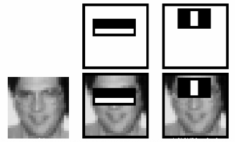  
**Figure 2.7: Haar Features being detected**

For this, we apply each and every feature on all the training images. For each feature, it finds the best threshold which will classify the faces to positive and negative. Obviously, there will be errors or misclassifications. We select the features with minimum error rate, which means they are the features that most accurately classify the face and non-face images. (The process is not as simple as this. Each image is given an equal weight in the beginning. After each classification, weights of misclassified images are increased. Then the same process is done. New error rates are calculated. Also new weights. The process is continued until the required accuracy or error rate is achieved or the required number of features are found).

The final classifier is a weighted sum of these weak classifiers. It is called weak because it alone can't classify the image, but together with others forms a strong classifier. The paper says even 200 features provide detection with 95% accuracy. Their final setup had around 6000 features. (Imagine a reduction from 160000+ features to 6000 features. That is a big gain).

So now you take an image. Take each 24x24 window. Apply 6000 features to it. Check if it is face or not. Wow.. Isn't it a little inefficient and time consuming? Yes, it is. The authors have a good solution for that.

In an image, most of the image is non-face region. So it is a better idea to have a simple method to check if a window is not a face region. If it is not, discard it in a single shot, and don't process it again. Instead, focus on regions where there can be a face. This way, we spend more time checking possible face regions.

For this they introduced the concept of **Cascade of Classifiers**. Instead of applying all 6000 features on a window, the features are grouped into different stages of classifiers and applied one-by-one. (Normally the first few stages will contain very many fewer features). If a window fails the first stage, discard it. We don't consider the remaining features on it. If it passes, apply the second stage of features and continue the process. The window which passes all stages is a face region. How is that plan!

The authors' detector had 6000+ features with 38 stages with 1, 10, 25, 25 and 50 features in the first five stages. (The two features in the above image are actually obtained as the best two features from Adaboost). According to the authors, on average 10 features out of 6000+ are evaluated per sub-window.

Haar-like cascade classifier was first used in face detection. A number of Haar-like features in a default window are extracted. In our experiment we use the 15 features described in [8]. The exhaustive set of Haar-like features in a default windows is over-complete and much more than the number of pixels. AdaBoost is an effective classifier to train from great number of features. It selects a small number of efficient features to build a weak classifier, stump classifier or classification and regression tree classifier. We can see that the weak classifier largely depends on the selection of positive and negative samples. So how to choose samples is a core problem in AdaBoost's training. Weak classifiers are then combined to form a strong classifier. The structure of a strong classifier is shown in the following figure.

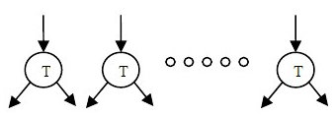

**Figure 2.8: The structure of AdaBoost**

To reduce computation time in the detection stage a cascade structure is adopted. The total time is reduced radically by processing large areas of the input image via simple classifiers and processing the rest of the input image via complex classifiers. The structure of cascade classifier is shown in Fig .3.7.

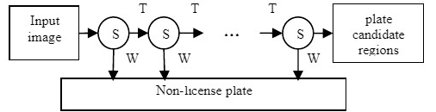  
**Figure 2.9: Structure of Cascade Classifier**

Cascade classifier structure. In our experiment we use two Haar-like cascade classifiers to form an ensemble classifier. Each classifier can detect more than one plate in an image. The two classifiers were trained using the same positive set with different negative set and different train parameters. In this way the accuracy was improved.

Below is a code for the Haar-Cascade

import cv2

plate_cascade=cv2.CascadeClassifier('cascade.xml')

img=cv2.imread('img.jpg')

gray=cv2.cvtColor(img,cv2.COLOR_BGR2GRAY)

plates=plate_cascade.detectMultiScale(gray,1.01,7)

for(x,y,w,h) in plates:

img=cv2.rectangle(img,(x,y),(x+w,y+h),(255,0,0),2)

cv2.imshow('img',img)

area=(x,y,x+w,y+h)

cv2.waitKey(0)

cv2.destroyAllWindows()

**2.2.4.3 Image Extraction**

For image extraction we use Masking. Masking is an image processing method in which we define a small “image piece” and use it to modify a larger image. Masking is the process that is underneath many types of image processing, including edge detection, motion detection, and noise reduction.

Now we have to segment our plate number. The input is the image of the plate, we will have to be able to extract the uni-character images. The result of this step, being used as input to the recognition phase, is of great importance. In a system of automatic reading of number plates.

Segmentation is one of the most important processes for the automatic identification of license plates, because any other step is based on it. If the segmentation fails, recognition phase will not be correct. To ensure proper segmentation, preliminary processing will have to be performed.

Given below is a sample code for masking the number plate region

mask=np.zeros(gray.shape,np.uint8)

cv2.drawContours(mask, [NumberPlateCnt], 0, 255, -1)

mask=cv2.bitwise_and(image,image, mask=mask)

cv2.imshow('mask',mask)

fname='C:/Users/Hirak/Desktop/Project/Plates/img'+str(no)+'.jpg'

cv2.imwrite(fname,mask)

**2.2.4.4 Image Recognition**

This phase is followed after the Image Extraction phase. In order to recognize the characters of the license plate “Image Recognition” needs to be done. For recognizing the license plate we use Optical Character Recognition (OCR).

1. **Optical Character Recognition (OCR)**

**Optical Character Recognition** involves the detection of text content on images and translation of the images to *encoded text* that the computer can easily understand. An image containing text is scanned and analyzed in order to identify the characters in it. Upon identification, the character is converted to machine-encoded text.

To us, text on an image is easily discernible and we are able to detect characters and read the text, but to a computer, it is all a series of dots.

The image is first scanned and the text and graphics elements are converted into a bitmap, which is essentially a matrix of black and white dots. The image is then pre-processed where the brightness and contrast are adjusted to enhance the accuracy of the process.

The image is now split into zones identifying the areas of interest such as where the images or text are and this helps kickoff the extraction process. The areas containing text can now be broken down further into lines and words and characters and now the software is able to match the characters through comparison and various detection algorithms. The final result is the text in the image that we're given.

The output can now be converted to other mediums such as word documents, PDFs, or even audio content through text-to-speech technologies.

1. **PyTesseract**

Python-tesseract is an optical character recognition (OCR) tool for python. That is, it will recognize and "read" the text embedded in images.

Python-tesseract is a wrapper for Google's Tesseract-OCR Engine. It is also useful as a stand-alone invocation script to tesseract, as it can read all image types supported by the Pillow and Leptonica imaging libraries, including jpeg, png, gif, bmp, tiff, and others. Additionally, if used as a script, Python-tesseract will print the recognized text instead of writing it to a file.

**2.2.4.5 Data storage phase.**

Vehicle record management in terms of registration, payment and online transaction needs to be stored and kept for verification and proper system operation because vehicles of different type may pass through and with different toll tax amount while neglecting Military vehicles, Police and Ambulances which are treated as toll free tax as they pass the bridge. To manage this variations and different records makes database to exist and support all the functions in record management. The database could contain valuable information like name, phone number, address, car number plate, wallet balance etc.

In this phase, after recognition of the number plate is done, it is matched with the database which contains the user’s details and subsequent balance is deducted from the wallet account.

**System Design**

This chapter covers the system design aspects of the Smart Toll Collection system project.

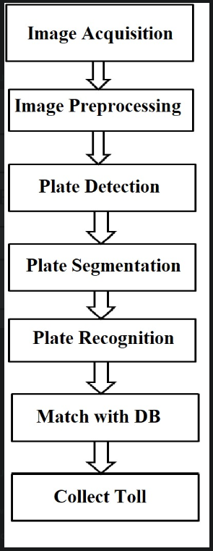  
**Figure 2.10: System pipeline**

The image is first acquired through the camera fitted in the Toll Gate. Various pre-processing techniques are then performed upon the captured image to remove noise and irregularities. After noise is removed, the co-ordinates of the license plate is found out either by Contour Detection Method or Haar Cascade Method. After the co-ordinates of the License Plate are found, the region inside it is then segmented out so that License Plate Recognition can be performed on the segmented image. We take both the binary and gray-scale versions of the segmented image and use PyTesseract(OCR) to read the License Plate characters. In some cases, the OCR can’t read the binary image, while in other cases, it can’t read the gray-scale image. So, both are taken and the best one is chosen among them. After the characters are recognized, it is then matched with the database which contains the user’s info which includes Name, License Plate number, Phone number and Wallet Balance and upon matching with the License Plate number, an appropriate sum is deducted from the user’s wallet. An SMS is also sent to alert the user that his/her car passed through the toll booth at the given time.

**2.3.1 Software Design**

**2.3.1.1 Database Design**

Database schema of a database system is its structure described in a formal language supported by the database management system (DBMS) and refers to the organization of data to create a blueprint of how a database will be constructed (divided into database tables). All constraints are expressible in the same language. The table below shows the database layout displaying the relationships between tables in a database on how registration of vehicles to the database will be performed as described below.

The database include the following tables;

*Number, user, phno, balance*

**2.3.1.2 Views in phpMyAdmin**

Registration of vehicle information (car table) where the number, user, phno, balance are seen as numbers because they are already registered.

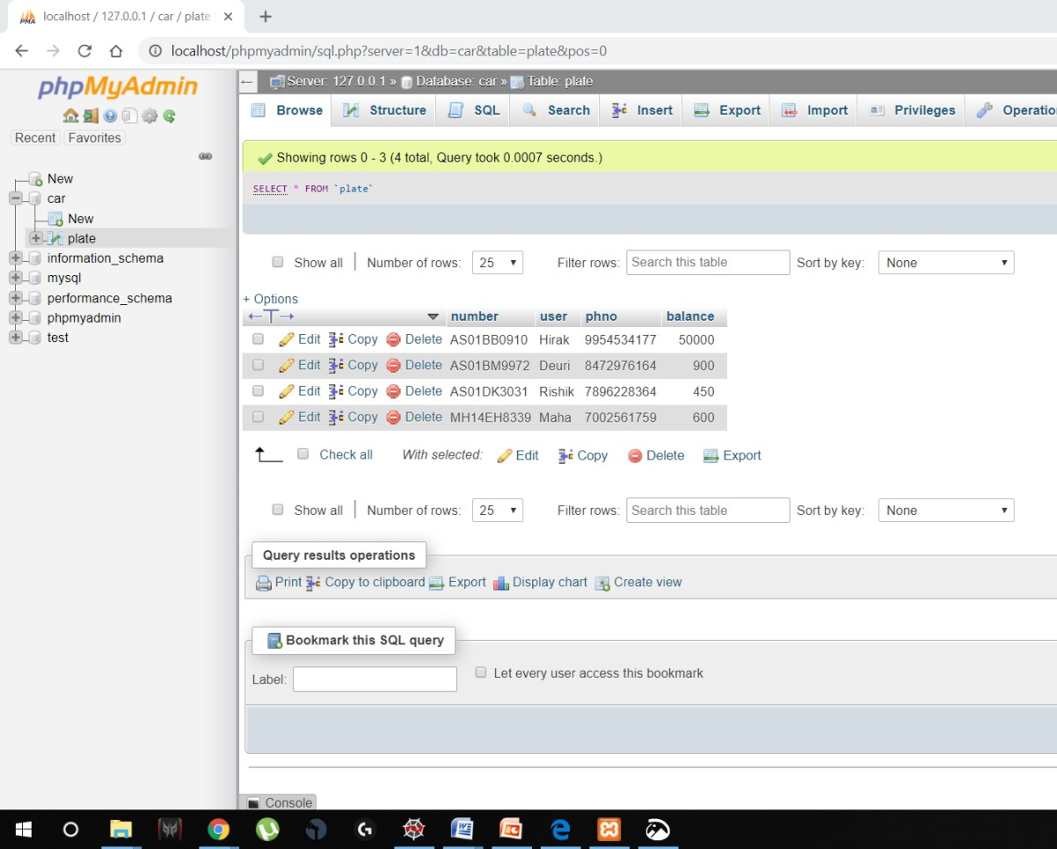

**Figure 2.11 : View in phpMyAdmin panel**

**Use of Python libraries/utilities**

* **OpenCV** (Open Source Computer Vision Library) is an open source computer vision and machine learning software library. It was built to provide a common infrastructure for computer vision applications and to accelerate the use of machine perception in the commercial products. The library has more than 2500 optimized algorithms, which includes a comprehensive set of both classic and machine learning algorithms.
* **NumPy** is a library for the Python Programming Language, adding support for large, multi-dimensional [arrays](https://en.m.wikipedia.org/wiki/Array_data_structure) and [matrices](https://en.m.wikipedia.org/wiki/Matrix_(math)), along with a large collection of [high-level](https://en.m.wikipedia.org/wiki/High-level_programming_language)[mathematical](https://en.m.wikipedia.org/wiki/Mathematics) [functions](https://en.m.wikipedia.org/wiki/Function_(mathematics)) to operate on these arrays.
* **Imutils -** A series of convenience functions to make basic image processing functions such as translation, rotation, resizing, skeletonization, and displaying Matplotlib images easier with OpenCV and both Python 2.7 and Python 3.
* **Time -** Python has defined a[module](https://www.geeksforgeeks.org/python-modules/), “time” which allows us to handle various operations regarding time, its conversions and representations, which find its use in various applications in life. The beginning of time is started measuring from 1 January, 12:00 am, 1970 and this very time is termed as “epoch” in Python.
* **Glob** - Glob is a general term used to define techniques to match specified pattern according to rules related Unix shell. Linux and Unix systems and shells also supports glob and also provide function glob() in system libraries. In this tutorial we will look glob() function usage in Python programming language.
* **Pytersseract -** Python-tesseract is an optical character recognition (OCR) tool for python. That is, it will recognize and "read" the text embedded in images. Python-tesseract is a wrapper for Google's Tesseract-OCR Engine. It is also useful as a stand-alone invocation script to tesseract, as it can read all image types supported by the Pillow and Leptonica imaging libraries, including jpeg, png, gif, bmp, tiff, and others. Additionally, if used as a script, Python-tesseract will print the recognized text instead of writing it to a file.
* **RE -** This library provides regular expression matching operations similar to those found in Perl. Both patterns and strings to be searched can be Unicode strings ([str](https://docs.python.org/3/library/stdtypes.html#str)) as well as 8-bit strings ([bytes](https://docs.python.org/3/library/stdtypes.html#bytes)). However, Unicode strings and 8-bit strings cannot be mixed: that is, you cannot match a Unicode string with a byte pattern or vice-versa; similarly, when asking for a substitution, the replacement string must be of the same type as both the pattern and the search string.

**2.3.2 SMS4India API**

SMS4India is an online SMS sending service that is targeted towards Indian users mainly. The website provides tools for sending SMS to any Indian phone number. They also provide an API that has a 25 SMS per account limit for testing purposes. This is used by our system to provide Short Messaging Service functionality.  
The API variables are explained as follows :

| **Parameter Name** | **Description** | **Type** | **Mandatory** |
| --- | --- | --- | --- |
| **apikey** | **apikey** is a unique identifier provided for verifying user. | Alphanumeric(32) | Yes |
| **secret** | **secret** is a unique identifier provided for verifying user. | Alphanumeric(16) | Yes |
| **usetype** | **usetype** is required for differentiate stage(for testing) and prod(for live) keys | String | Yes |
| **phone** | **phone**no is required for sending message. | valid indian phone number | Yes |
| **message** | **message**text is required for sending message. | String (upto 500) | Yes |
| **senderid** | **senderid**is required for sending message. | Alpha (6) | Yes |

**Table 1: SMS4India API variables**

**Template code for API by SMS4India**

import requests

import json

URL = 'https://www.sms4india.com/api/v1/sendCampaign'

# get request

def sendPostRequest(reqUrl, apiKey, secretKey, useType, phoneNo, senderId, textMessage):

req_params = {

'apikey':apiKey,

'secret':secretKey,

'usetype':useType,

'phone': phoneNo,

'message':textMessage,

'senderid':senderId

}

return requests.post(reqUrl, req_params)

# get response

response = sendPostRequest(URL, 'provided-api-key', 'provided-secret', 'prod/stage', 'valid-to-mobile', 'active-sender-id', 'message-text' )

"""

Note:- you must provide apikey, secretkey, usetype, mobile, senderid and message values and then requst to api

"""

print response.text

**Chapter 3 - Results and Discussion**

**3.1 Results**

This chapter concludes on the results including failure and success; concerning the Smart Toll Collection system. The testing dataset includes 75 images out of which 60 were of Indian cars and the remaining were from Foreign Countries.

**Figure 3.1: Results Graph**

**Figure 3.2: Time comparison Graph**

From the above two graphs it can be seen that even though Contour Detection takes very less time to compute, but Haar-Cascade yields better results than Contour detection.

**Chapter 4 - Conclusion and Future scope**

**4.1 Conclusion**

Some of the challenges of this project are making the system work in toll points, each with its specified database for keeping records of the accounts for the respective vehicles. Also the ability of the system to detect a vehicle is irrespective of the weather condition like excessive rain or heat and irrespective of the area of location within a specified distance.

The project has therefore been implemented only with minor problems in recognition phase which might be due to low resolution of the car images that were obtained via mobile phones.

**4.2Future Scopes**

This project can act as a curtain raiser for others to see outside in a sense that, its solid foundation leaves a room for plenty of further developments in improving the system so as to make it serve the people better.

Some of the future scopes for improvements are like integrating it with network for quick response rather than keeping the whole program in a single computer also the use better camera since some plat manufacturers ignore the quality of number plate for an APR to function well.

**References**

[1] Juan, Zhang, and Xu Jianjun. "Research of overall program on highway toll collection system." Information Science and Technology (ICIST), 2011 International Conference on. IEEE, 2011

[2] Kuo-Ming, H., Ching-Tang, H. . A Real-Time Mobile Vehicle License Plate Detection and Recognition. Retrieved from Tamkang Journal of Science and Engineering, Vol. 13, No. 4, pp. 433-442 (2010)

[3] Amirgaliyev Beibut , Kazakhstan Kairanbay Magzhan , Kazakhstan Kenshimov Chingiz "Effective Algorithms and Methods for Automatic Number Plate Recognition" International Conference on Application of Information and Communication Technologies (AICT). IEEE, 2014

[4] Benjapa, R., Kittawee, K., Paruhat P., Thaweesak Y. . License Plate Detection Based on Template Matching Algorithm. Retrieved from International Conference on Computer and Communication Technologies (ICCCT'2012) May 26-27, 2012 Phuket

[5] Cem Demirkır, Bulent Sankur .Object Detection Using Haar Feature Selection Optimization. Signal Processing and Communications Applications (SIU), IEEE ,2006

[6]Pablo Arbeláez, Michael Maire et al. Contour Detection and Hierarchical Image Segmentation. IEEE Transactions on Pattern Analysis and Machine Intelligence ( Volume: 33 , Issue: 5 , May 2011 )

[7] Klaus Finkenzeller, “RFID Handbook: Radio-Frequency Identification Fundamentals and Applications”. John Wiley & Sons, 2000

[8] Rayson Laroca, Evair Severo, et al. International Joint Conference on Neural Networks.(IJCNN), 2018